**How to mount an Azure Blob Storage container on Linux with BlobFuse2**

**Step 1:** Create a Virtual Machine (VM)

* Log in to the Azure portal.
* Navigate to Virtual Machines -> Create a virtual machine.
* Configure and Complete the setup and create the VM

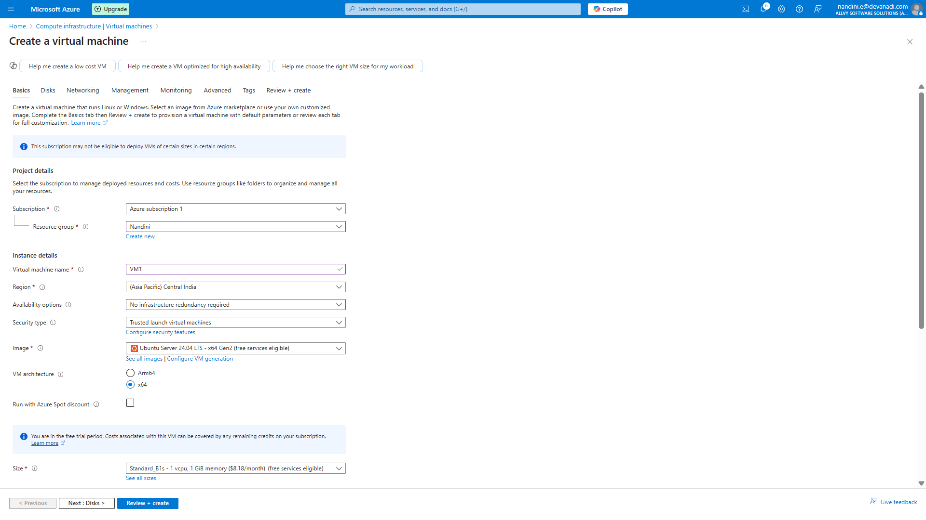

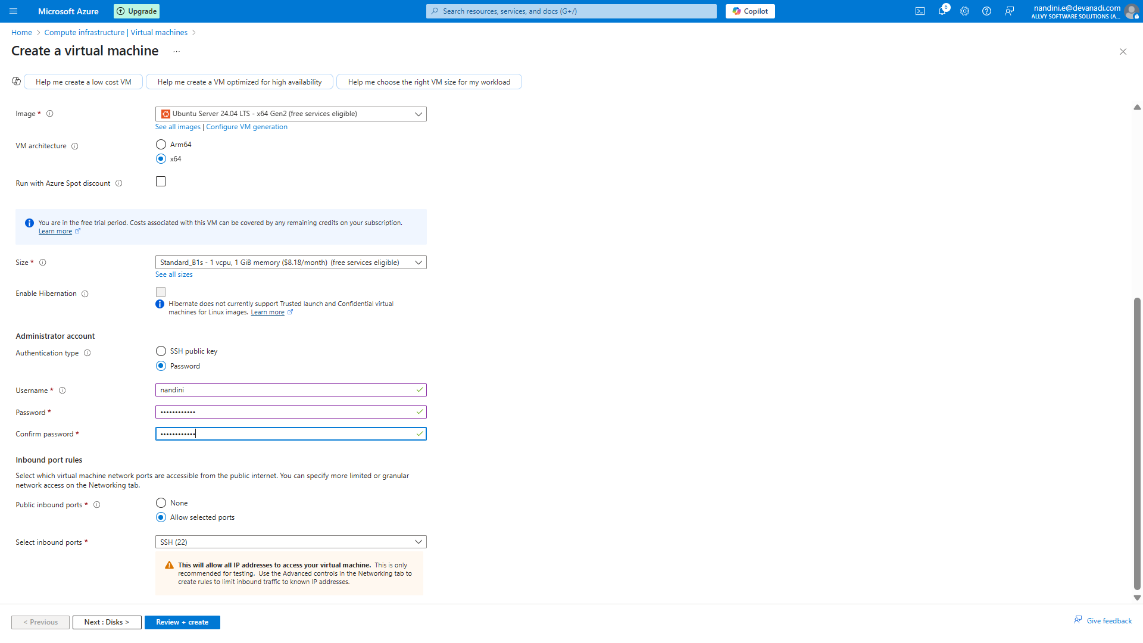

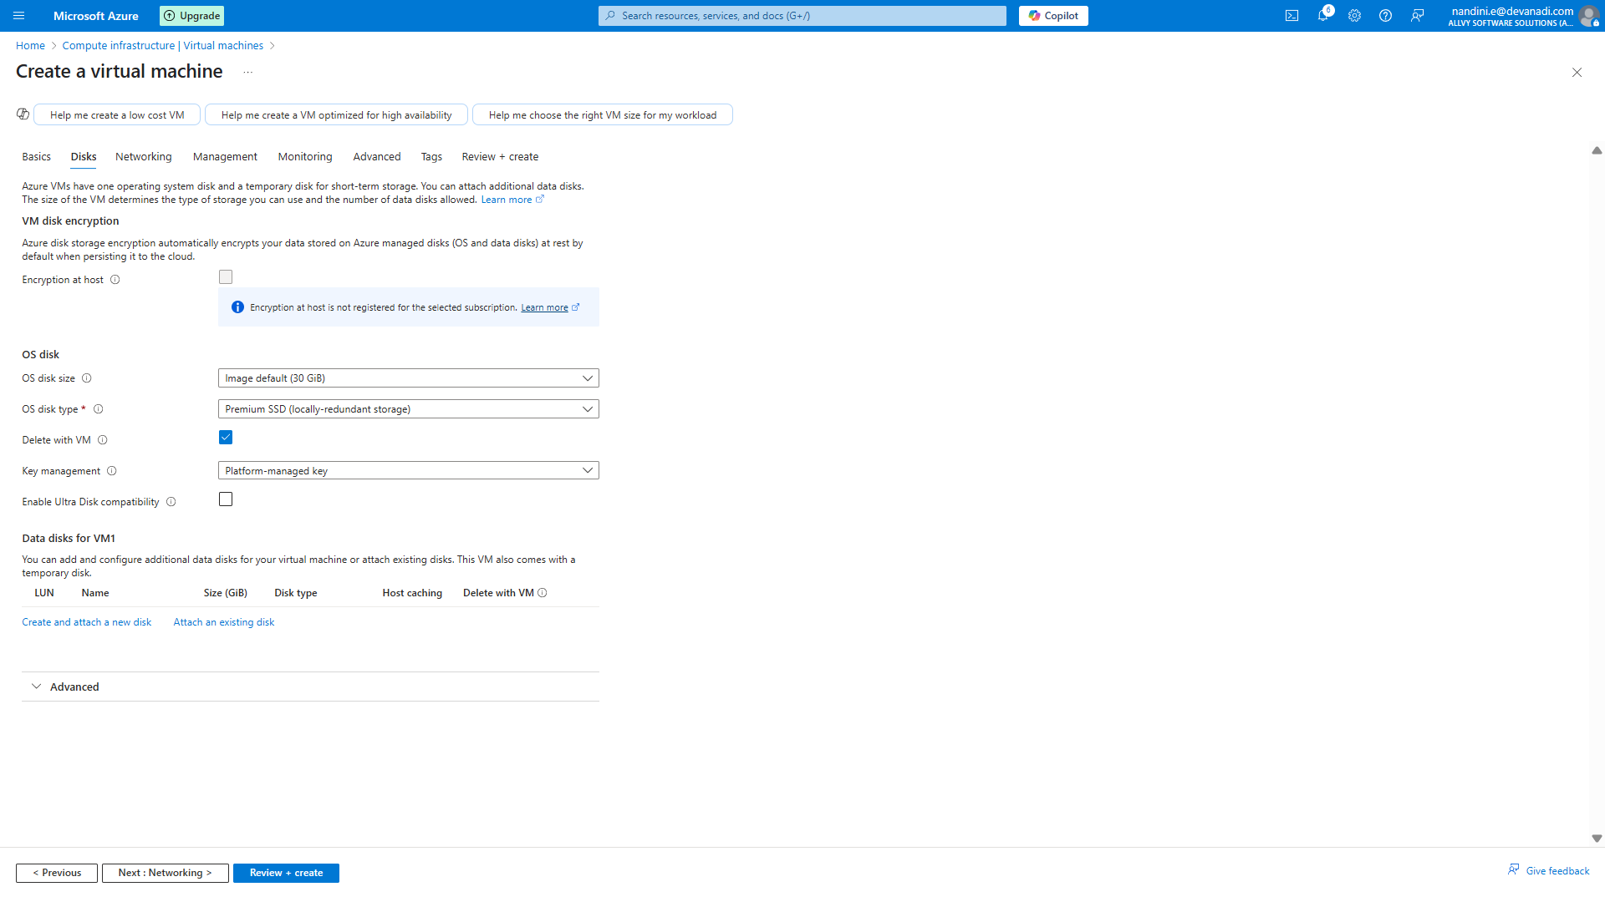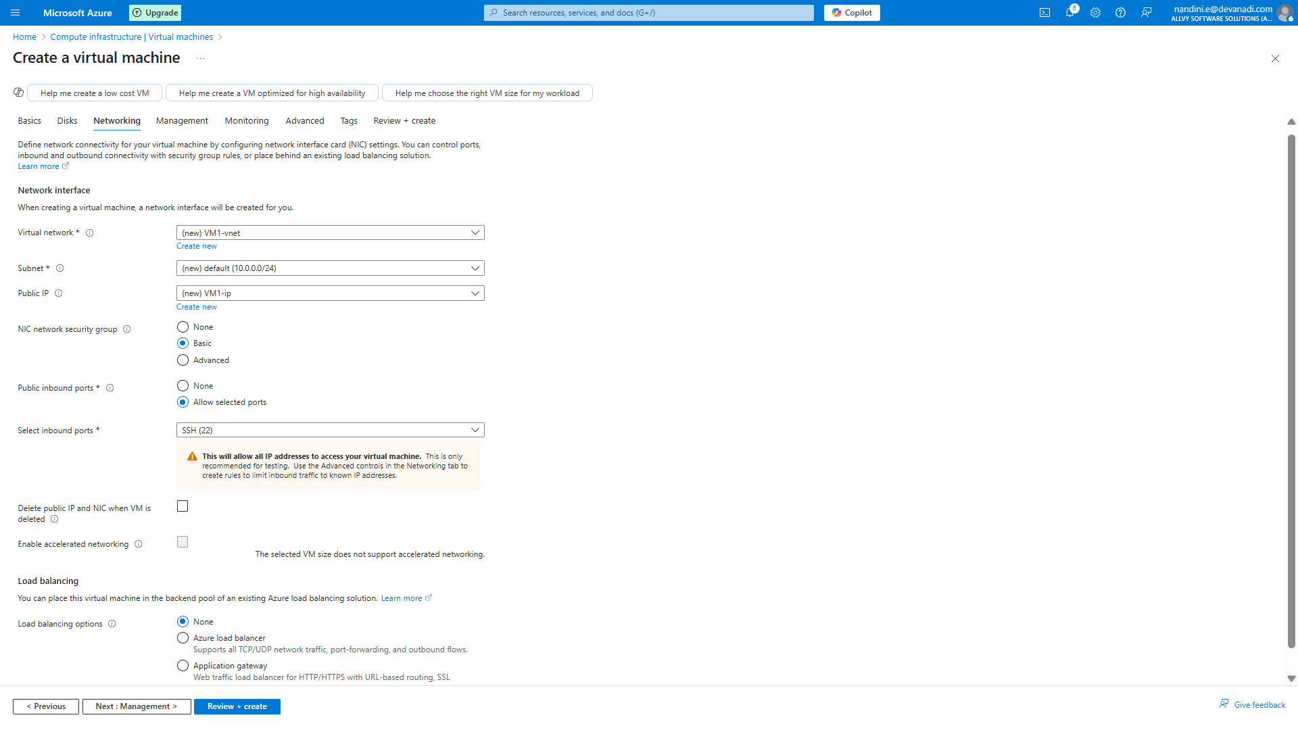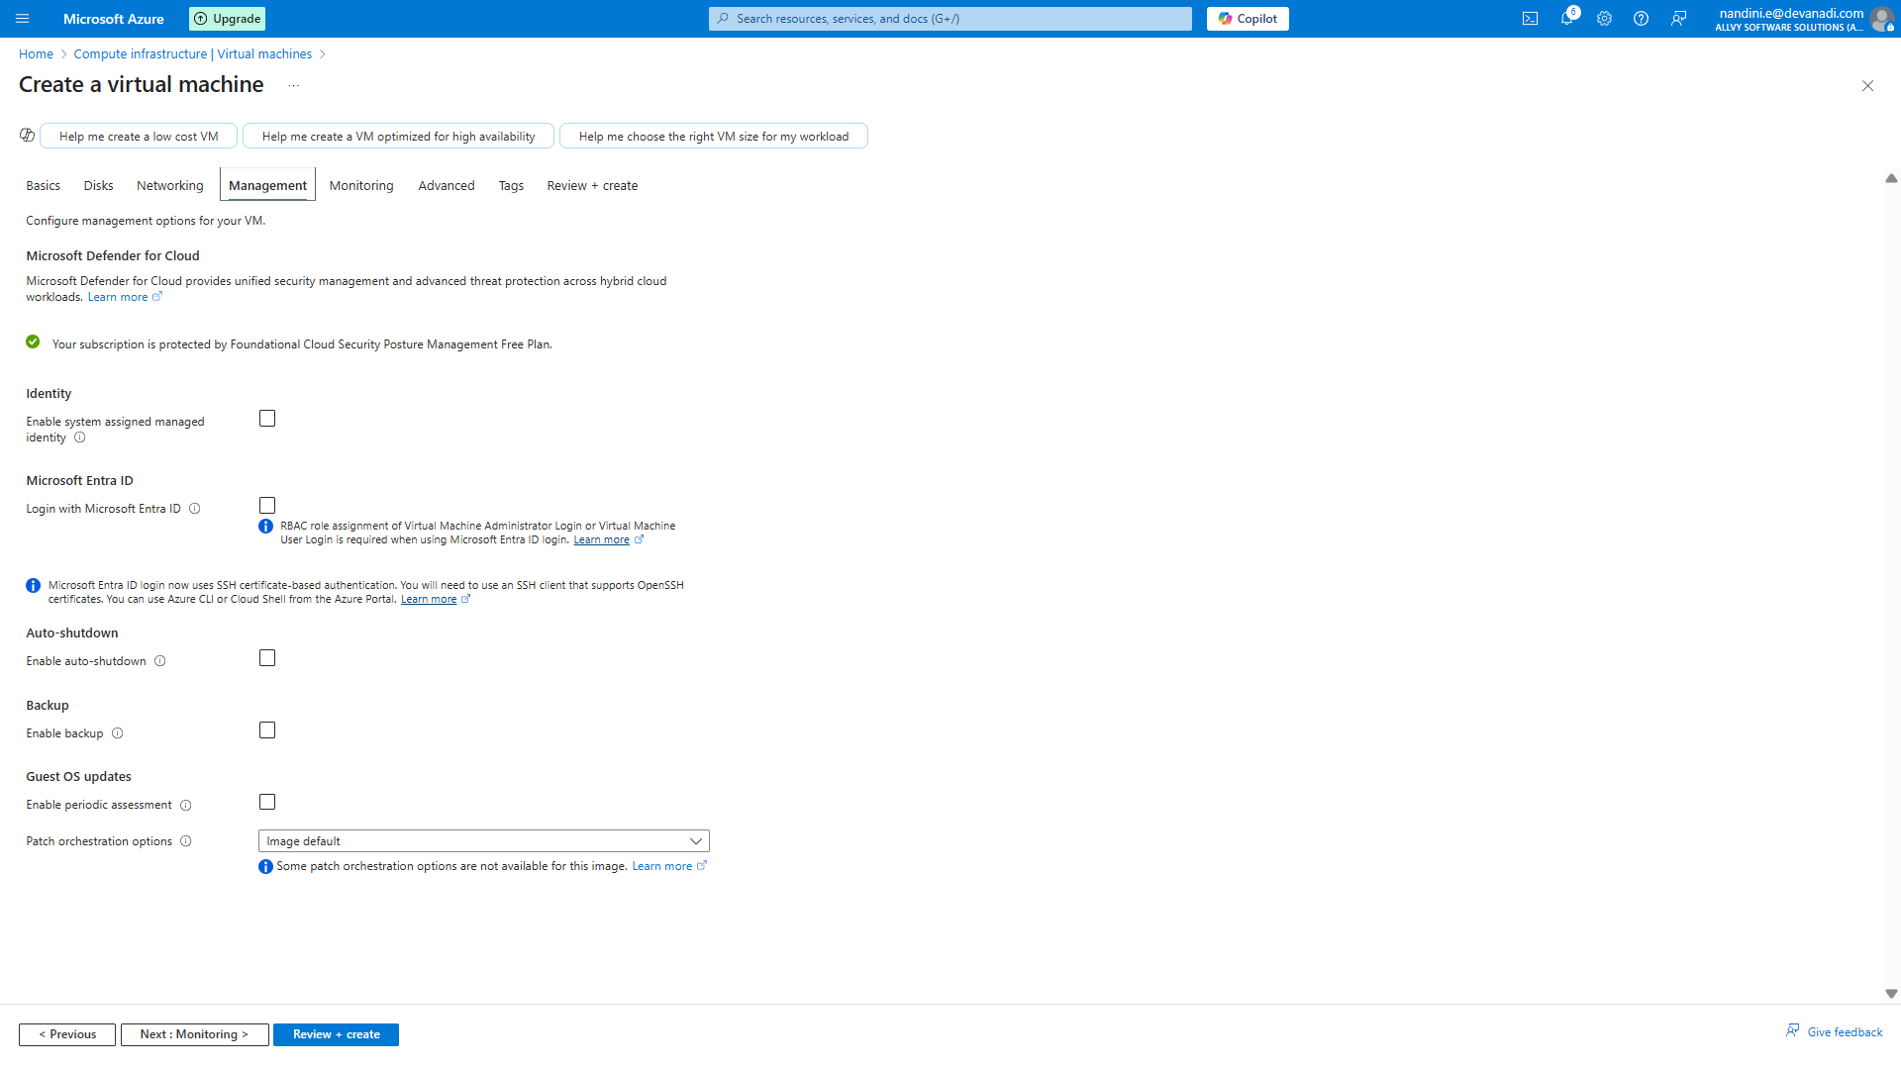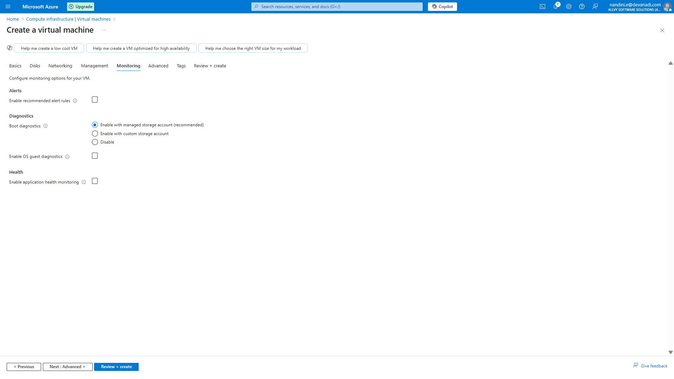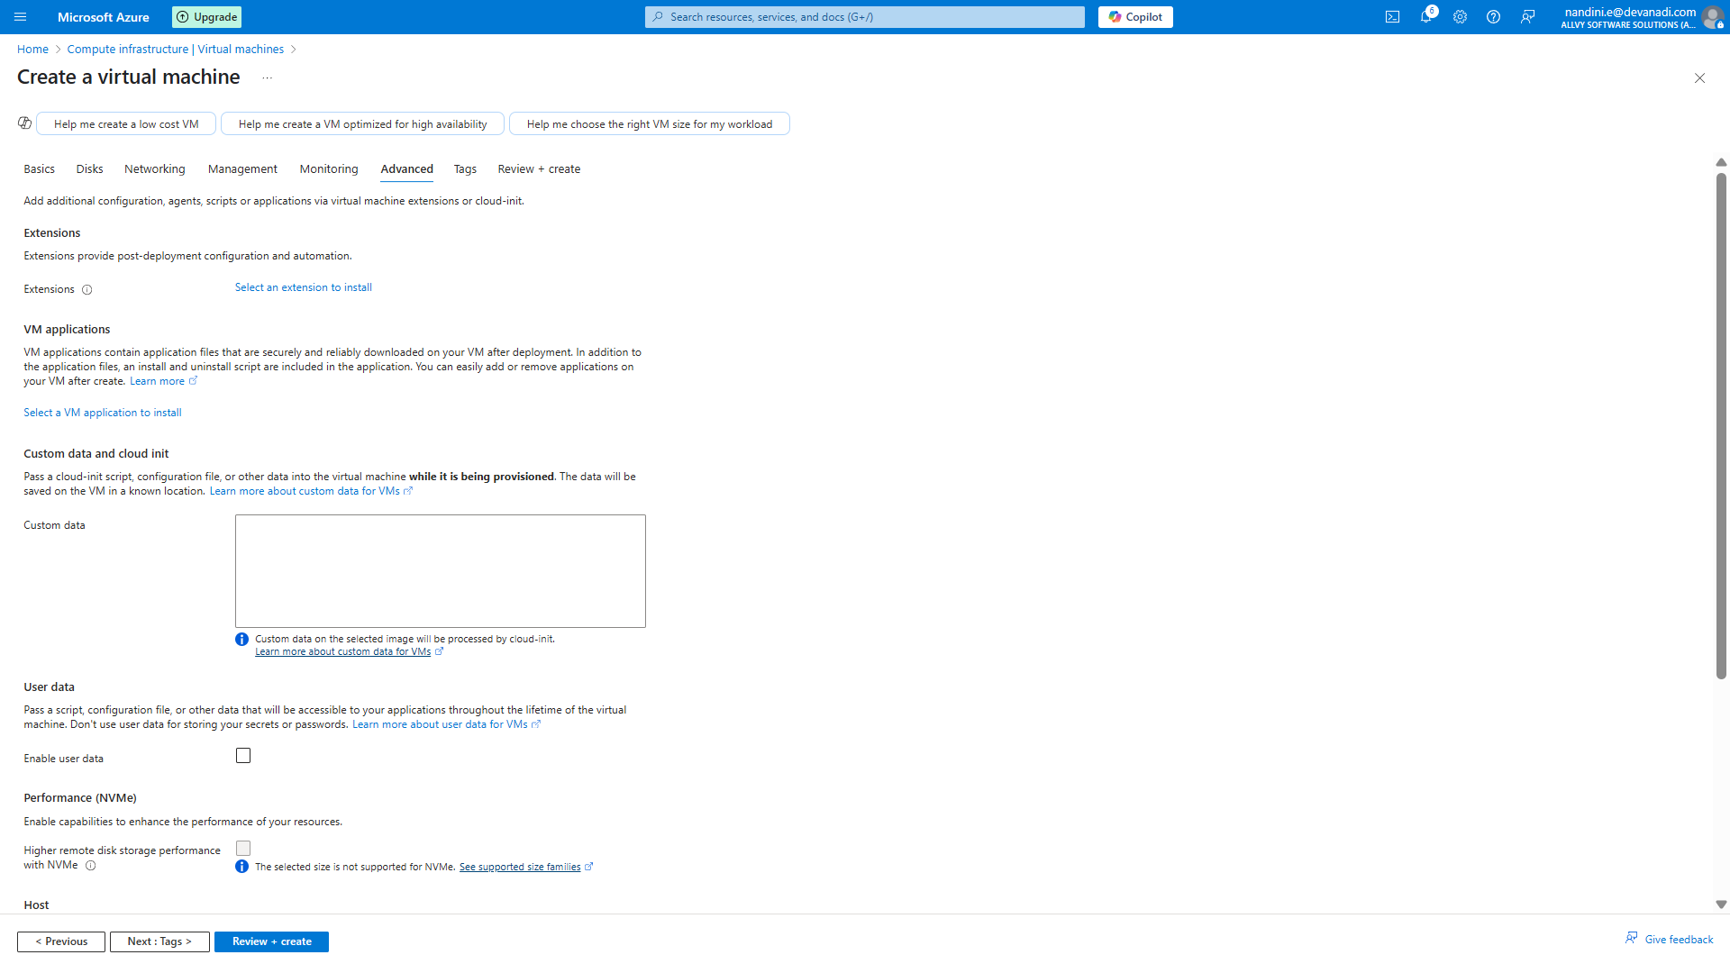 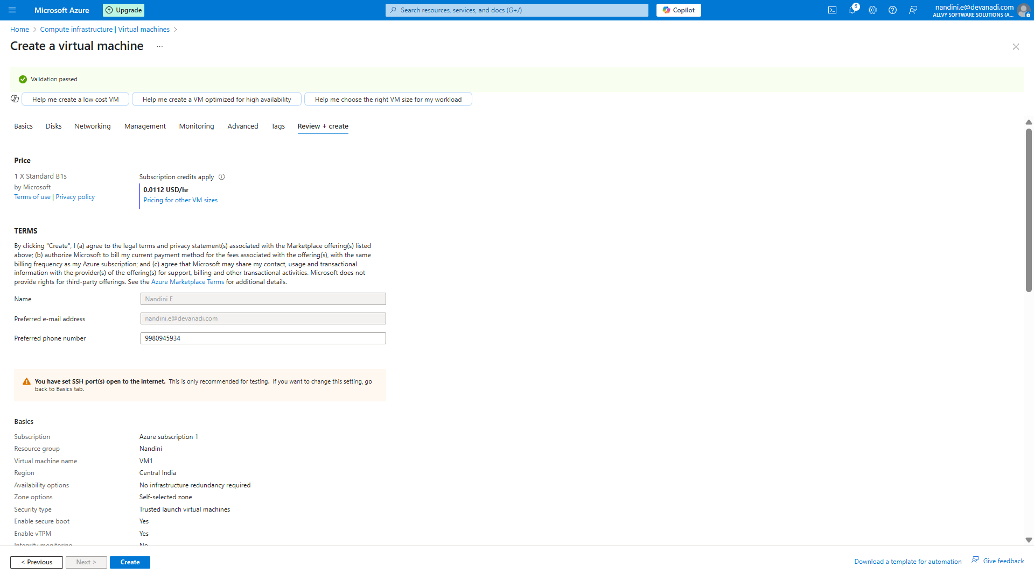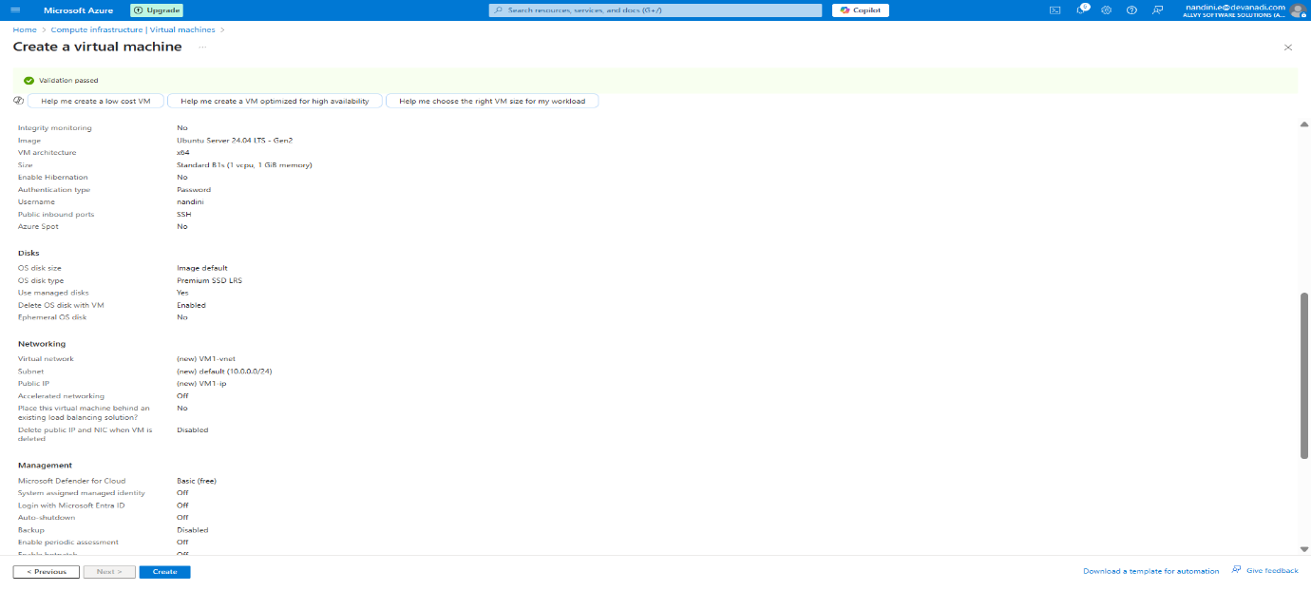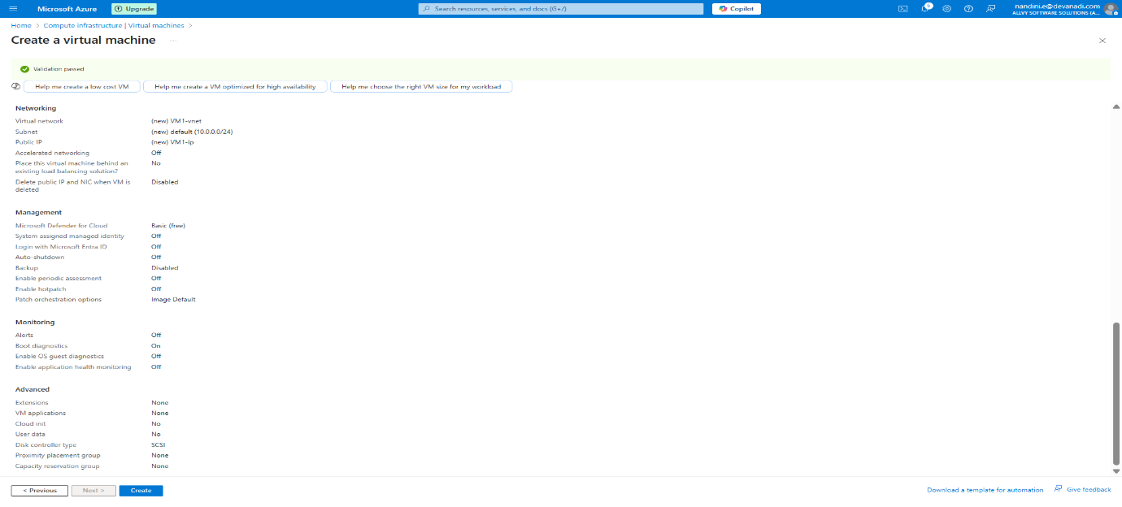

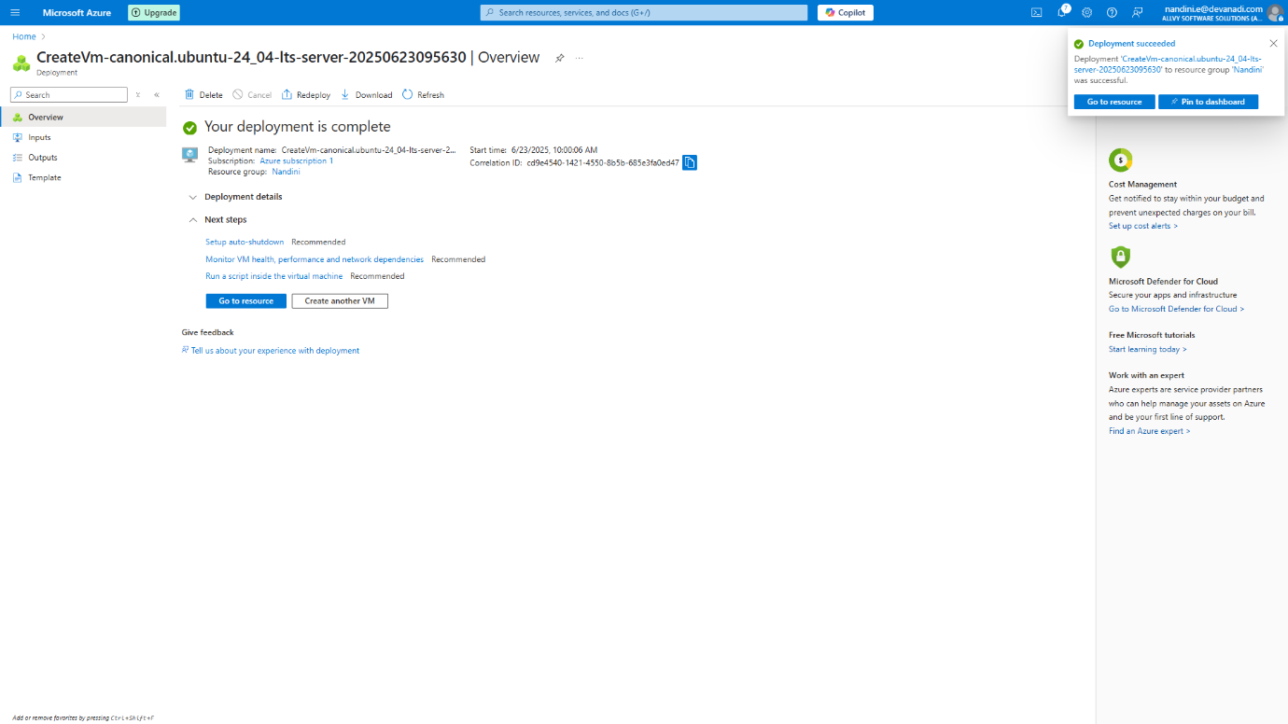

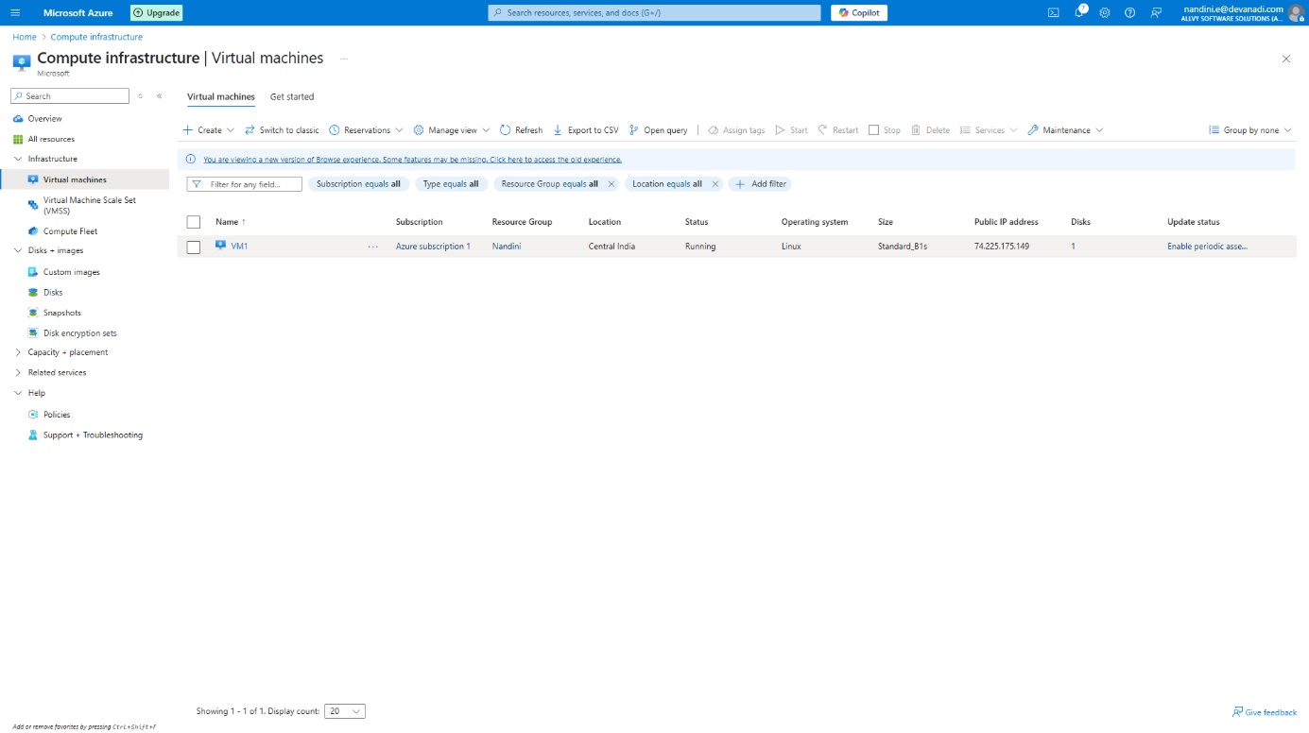

**Step2:** Create a Storage Account

Go to **Storage Accounts** -> **Create**

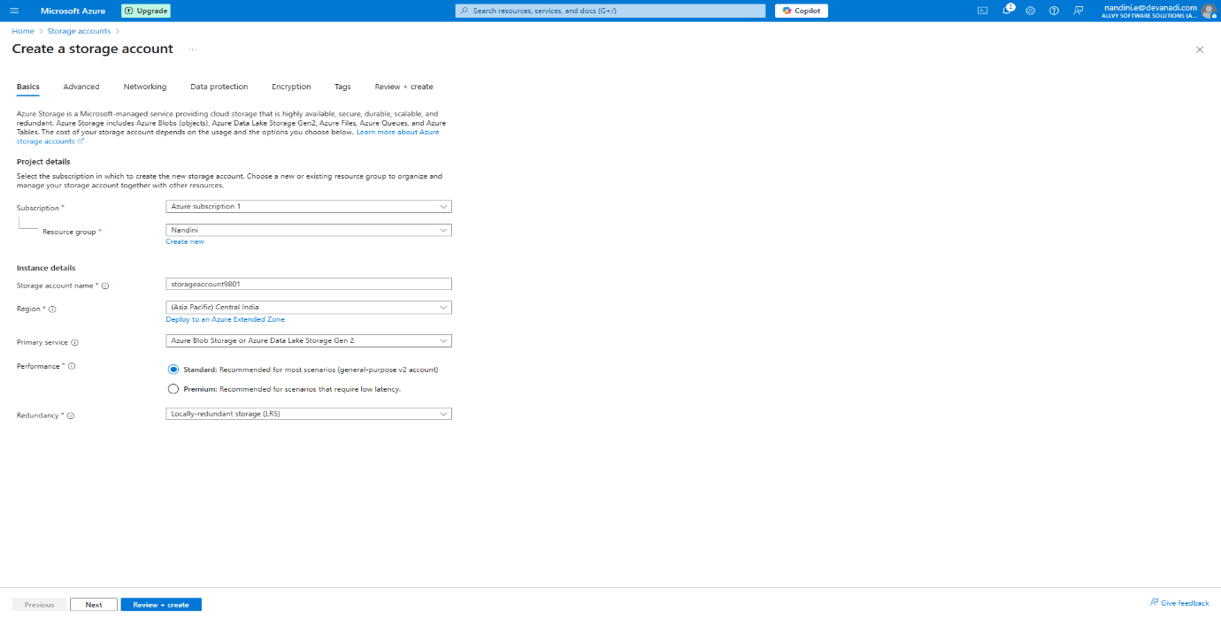

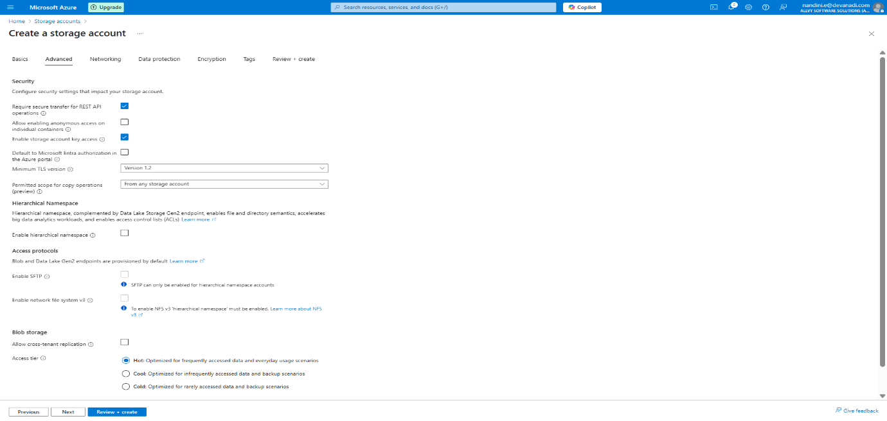

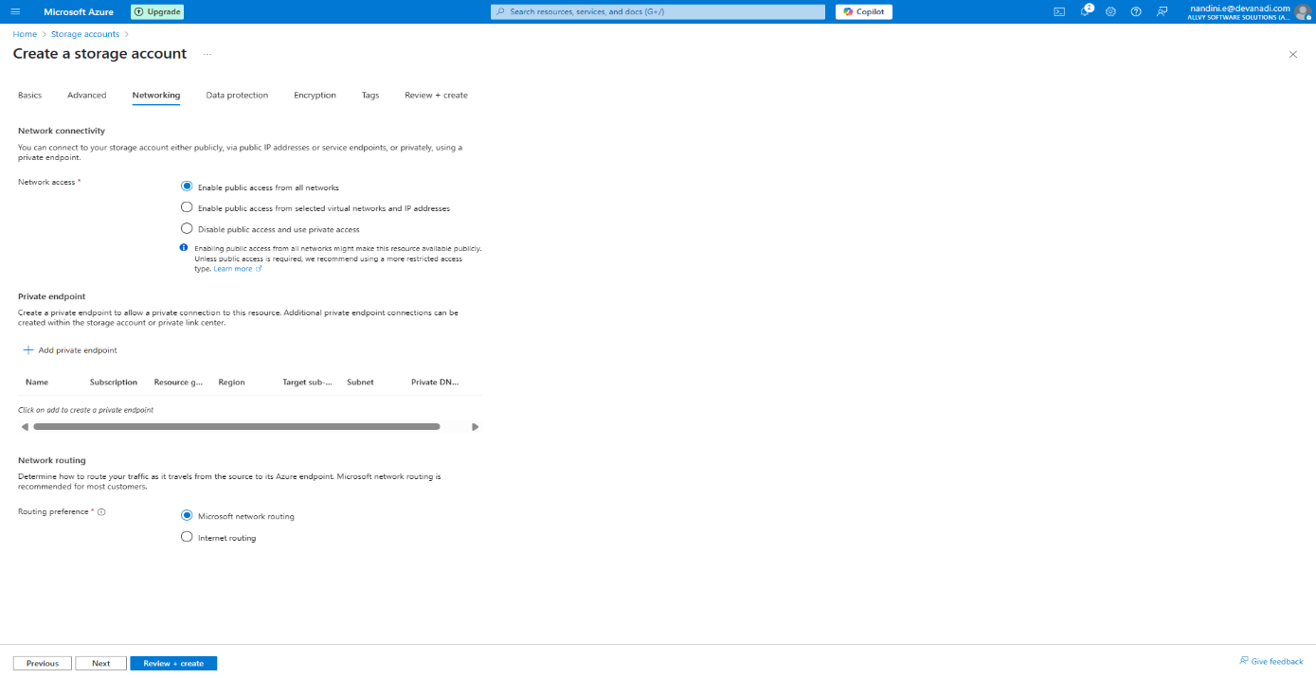

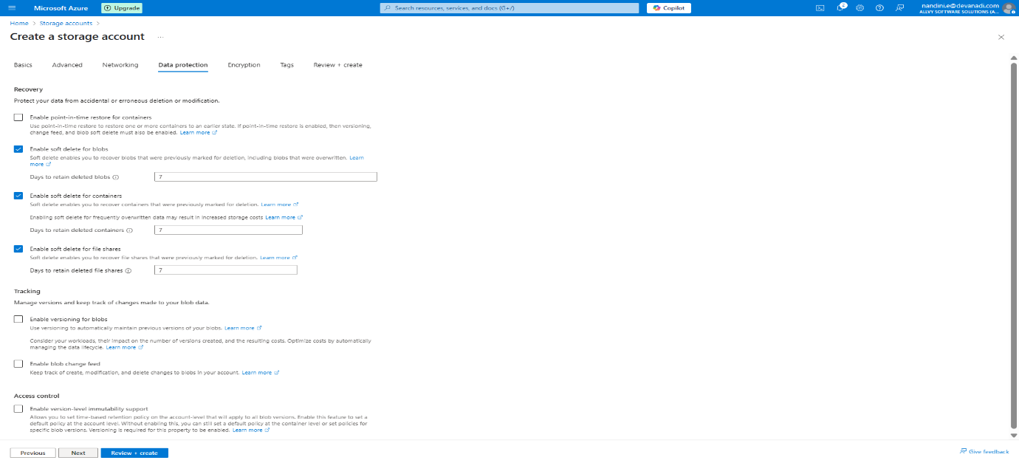 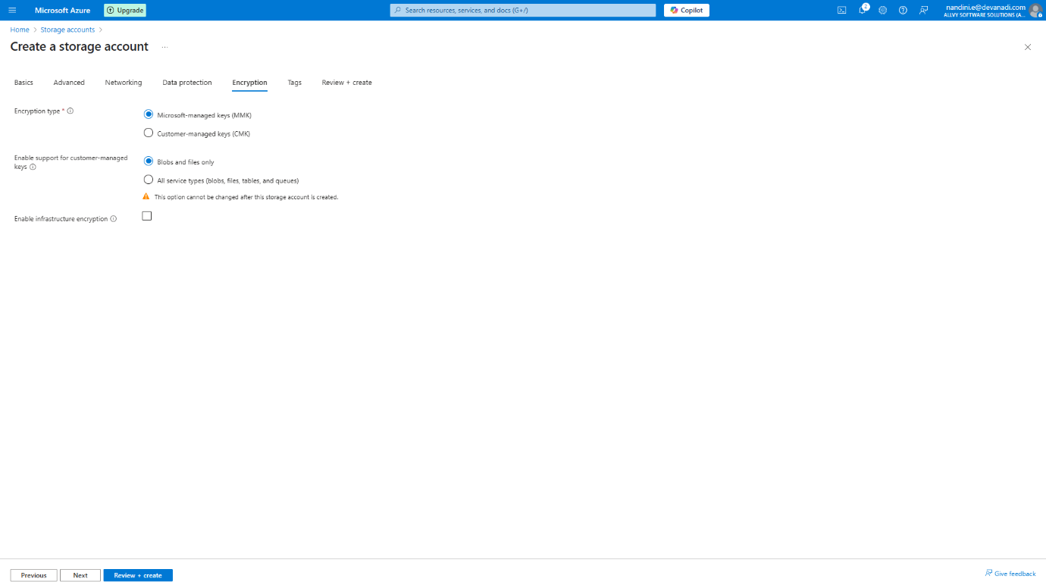 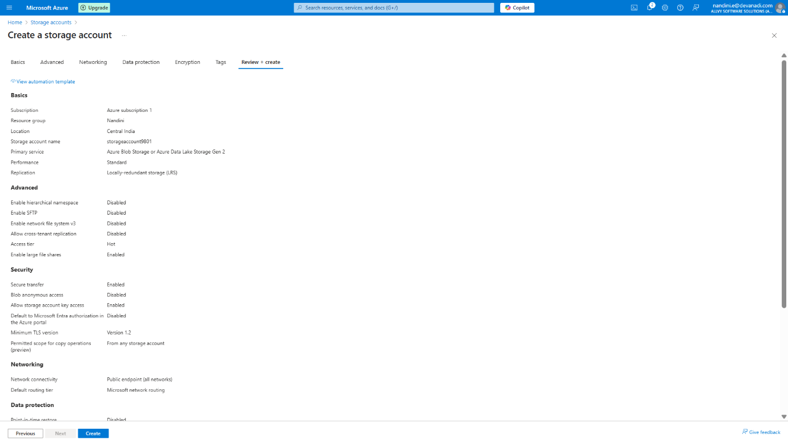

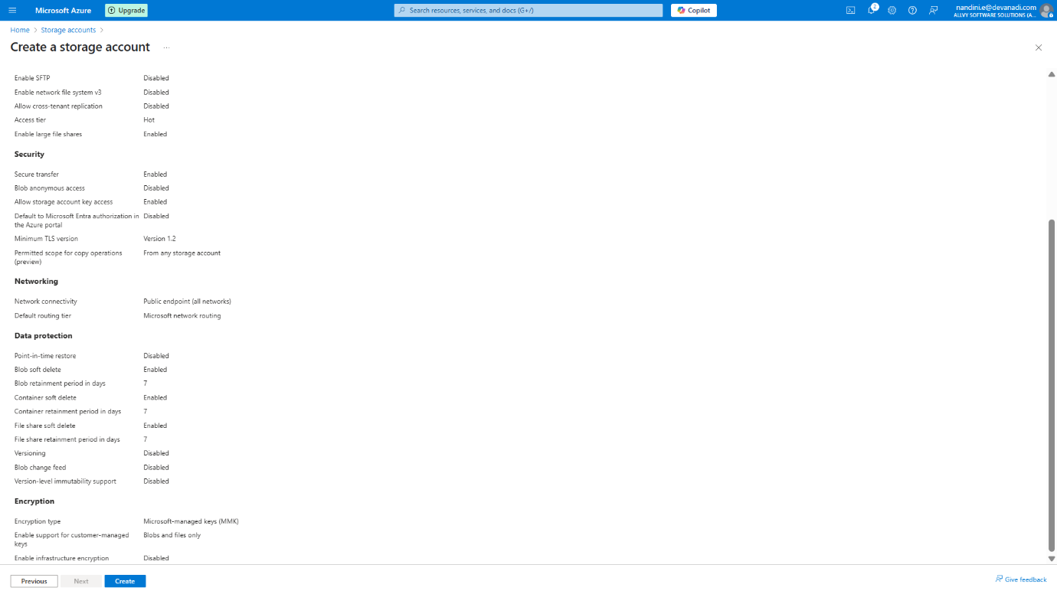

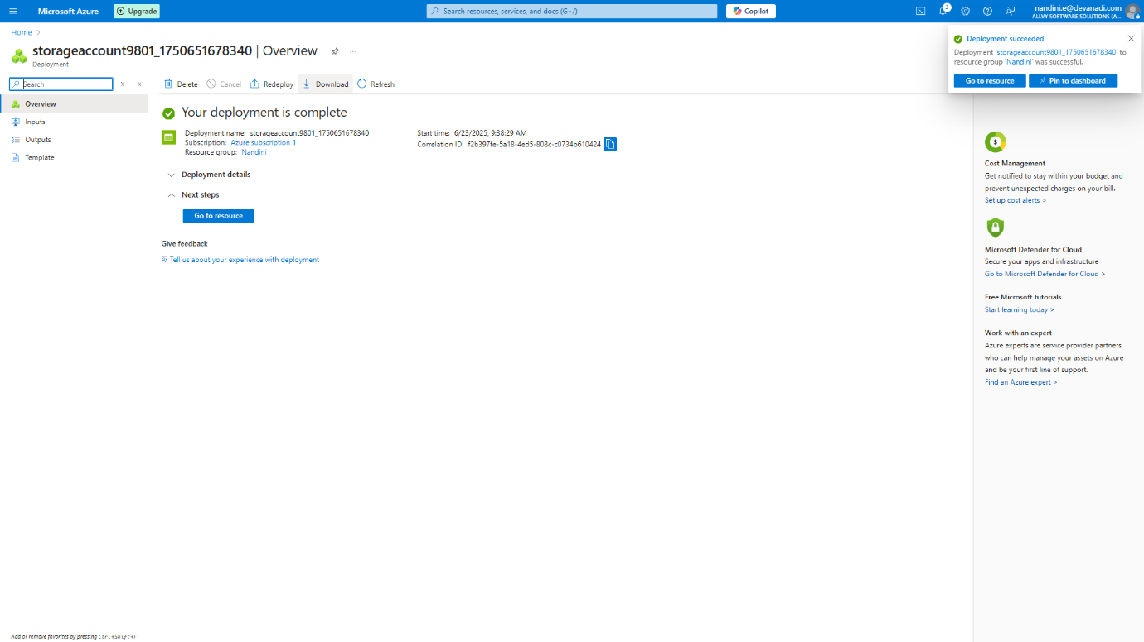

Once created, open the Storage Account

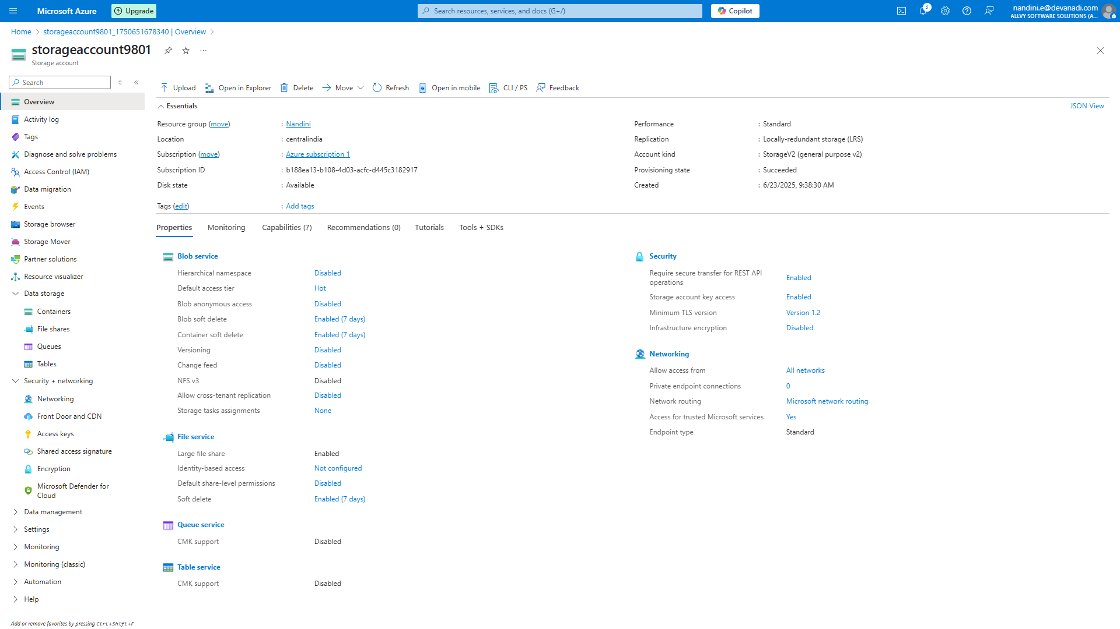

**Step3:** Create a Blob Container

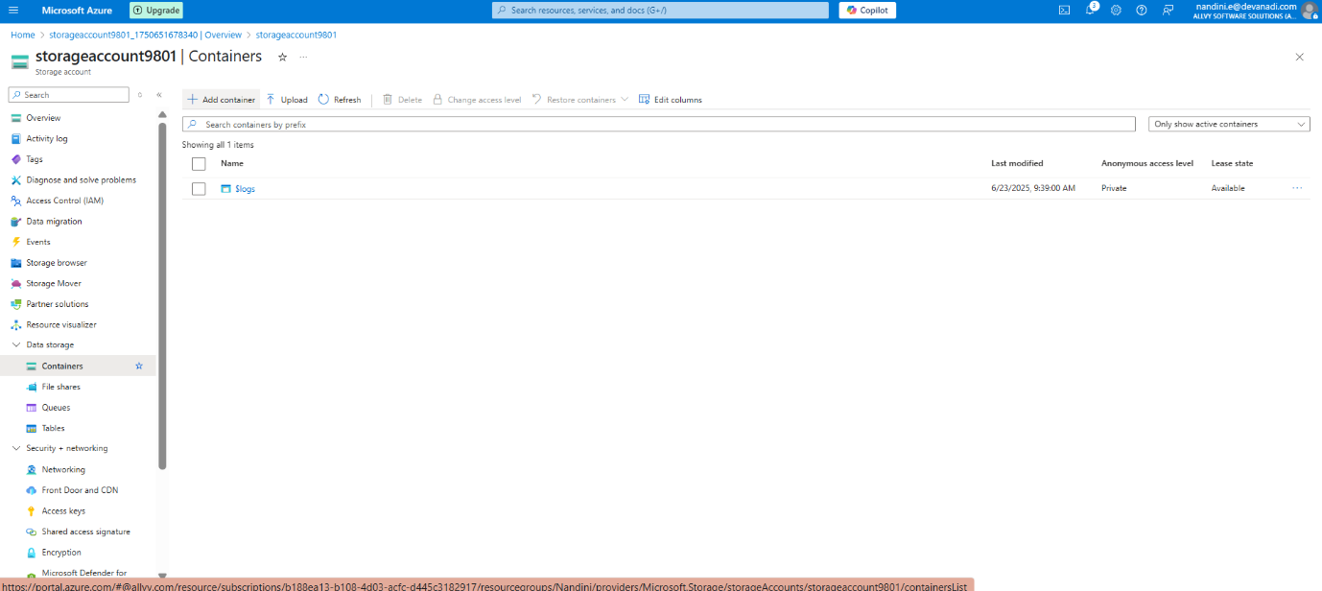

Click + Add container

Name: storagecontainer01

Click create

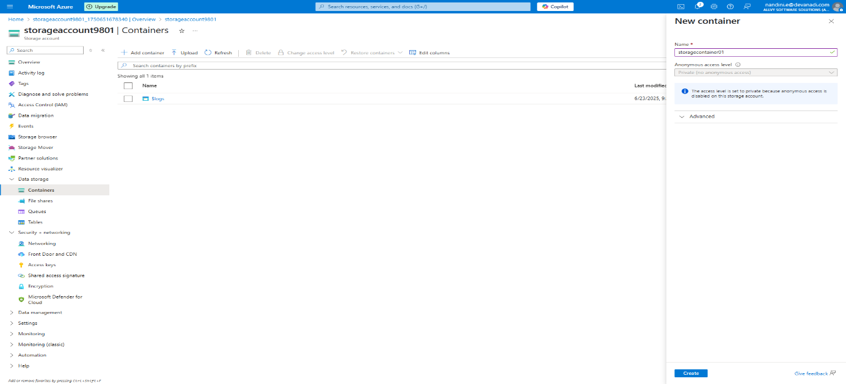

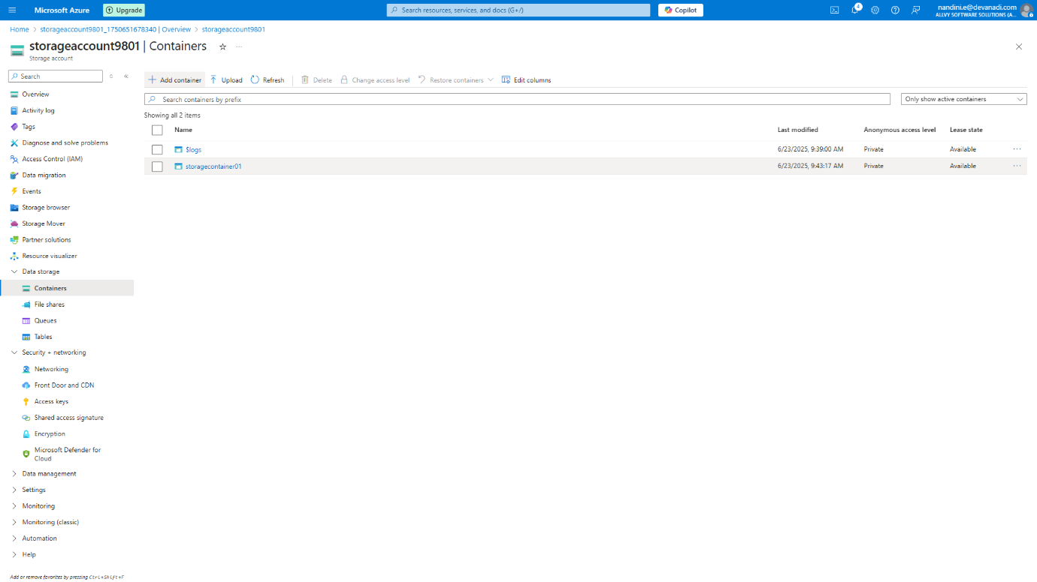

Change Access Level

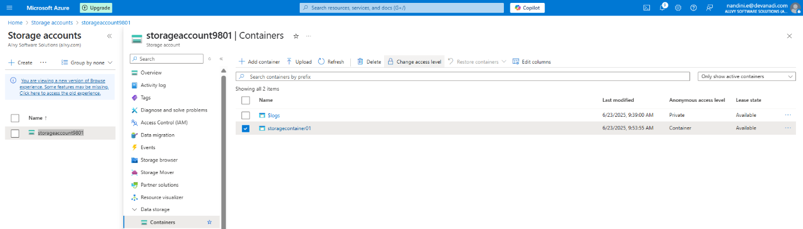

Access Level is Disable so we need to enable

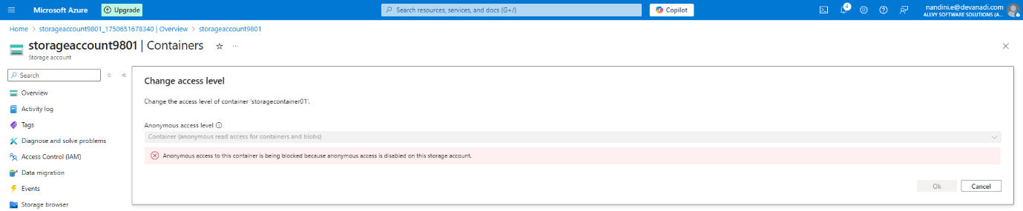

Go to Configuration and enable blob anonymous access

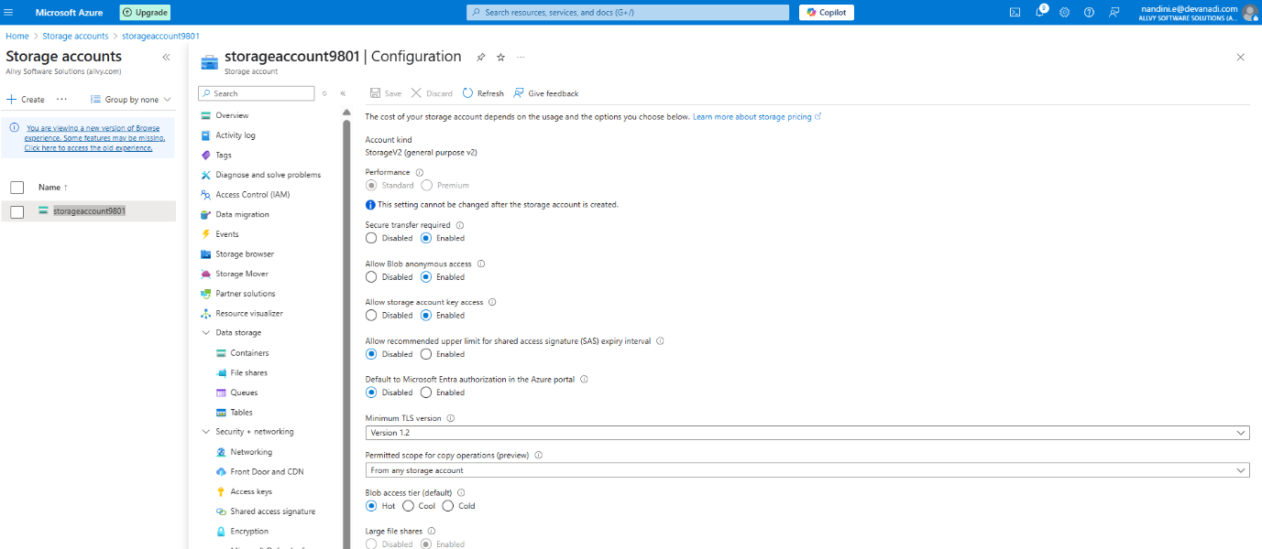

Now we can change access level

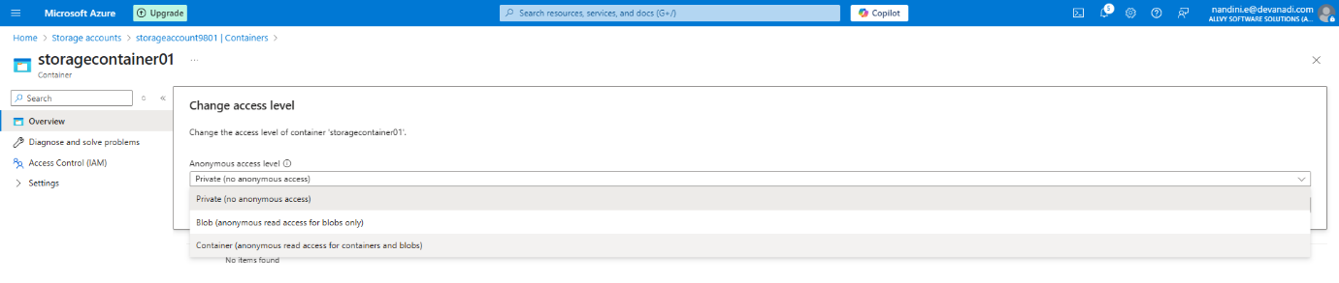

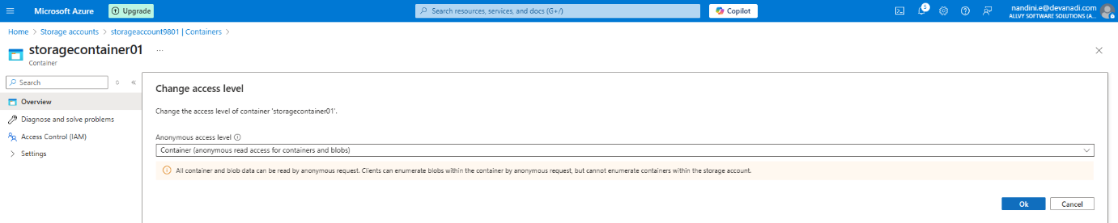

**Step 4:** Connect to the VM Using PuTTY

* Go to your VM resource in the Azure portal.
* Copy the **public IP address**.

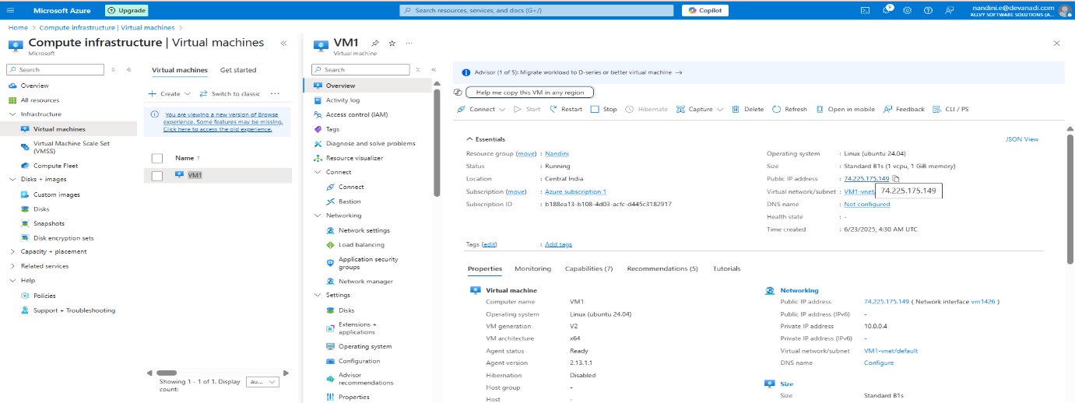

Open **PuTTY** and:

* Paste the IP address

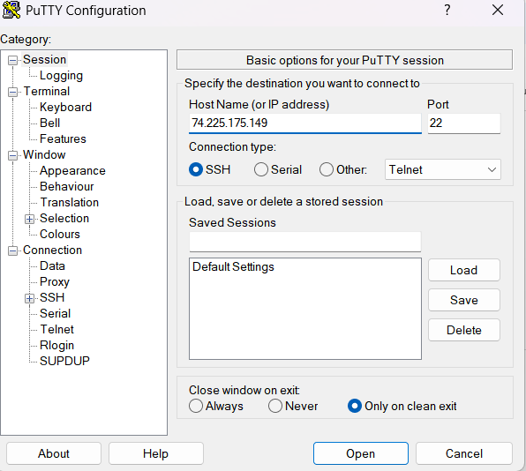

* Login with your **username** and **password**

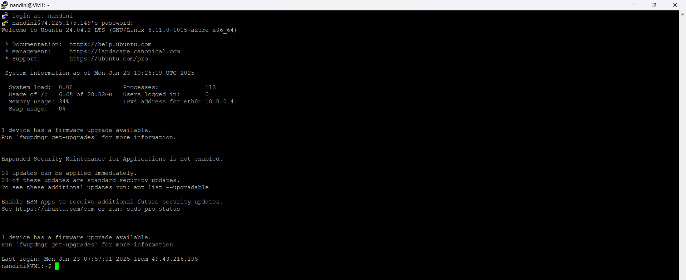

**Step 5:** Confirm Ubuntu Version

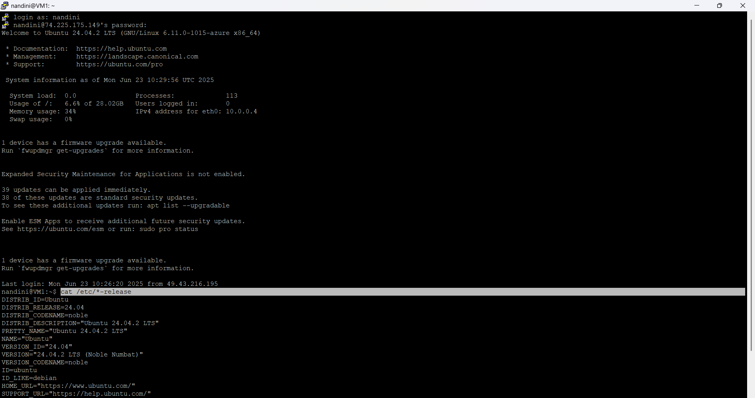

**Step 6:** Add Microsoft Package Repository

|  |
| --- |
| wget https://packages.microsoft.com/config/ubuntu/24.04/packages-microsoft-prod.deb  sudo dpkg -i packages-microsoft-prod.deb  sudo apt-get update |

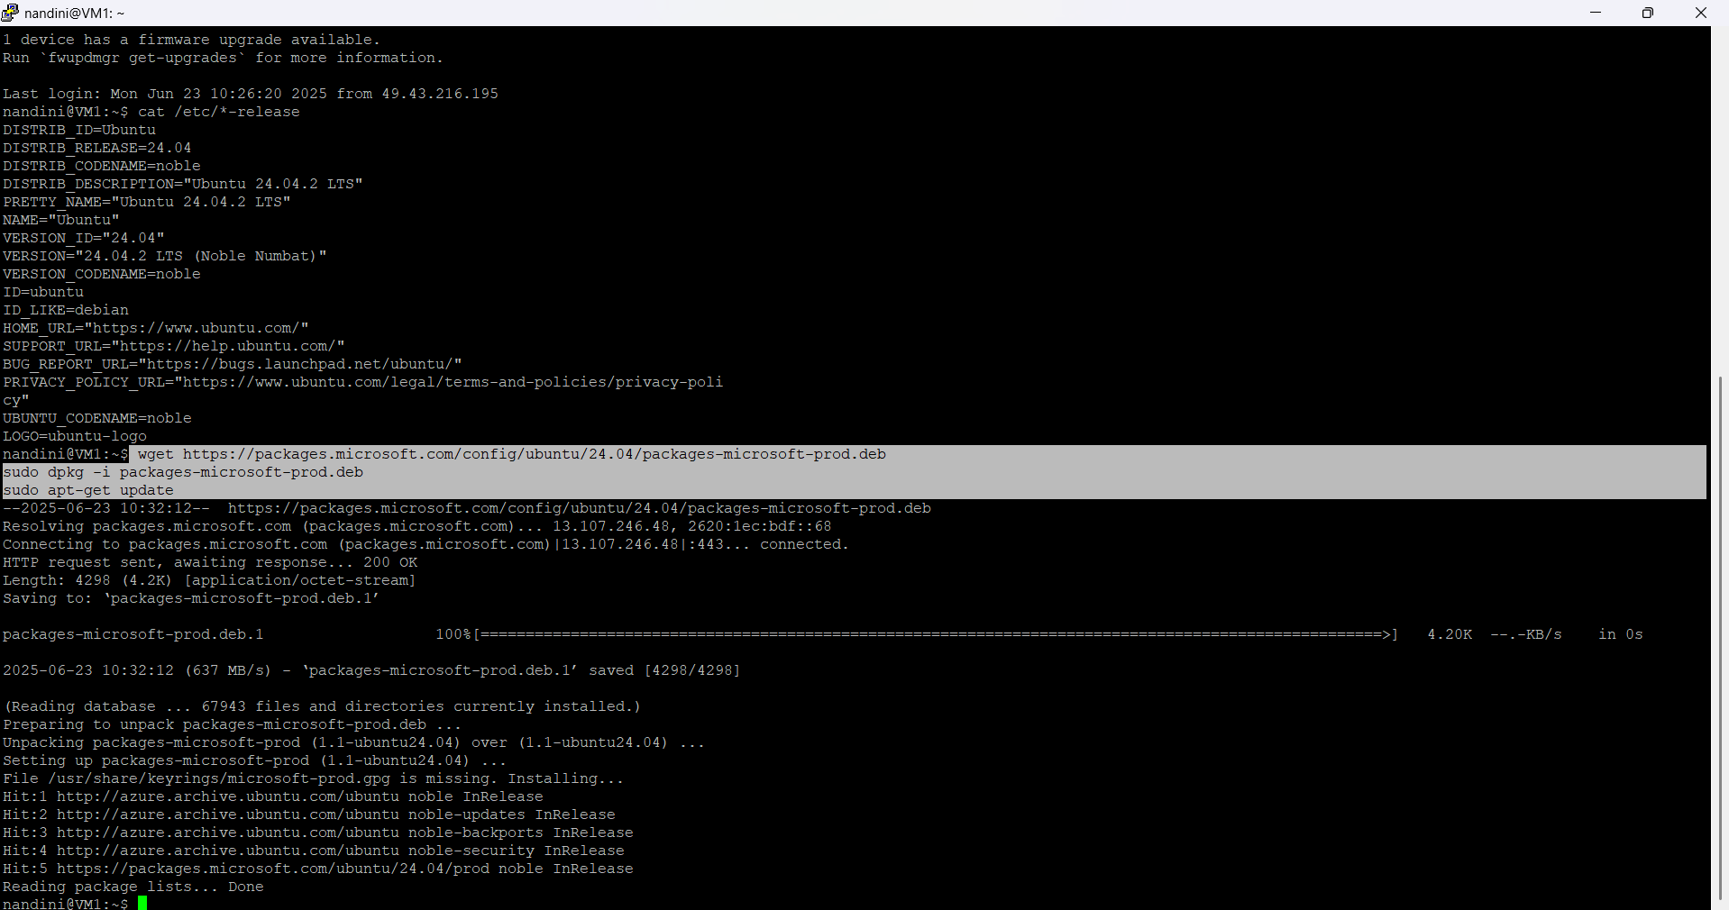

**Step 7:** Install BlobFuse2

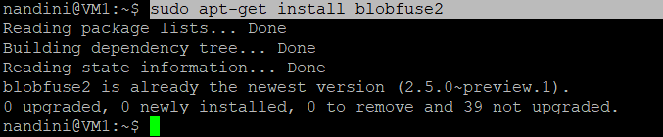

**Step 8:** Install nano

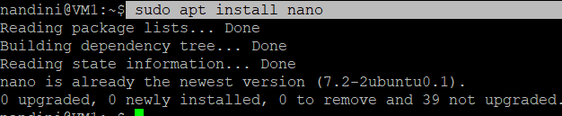

**Step 9:** Create BlobFuse2 Configuration File

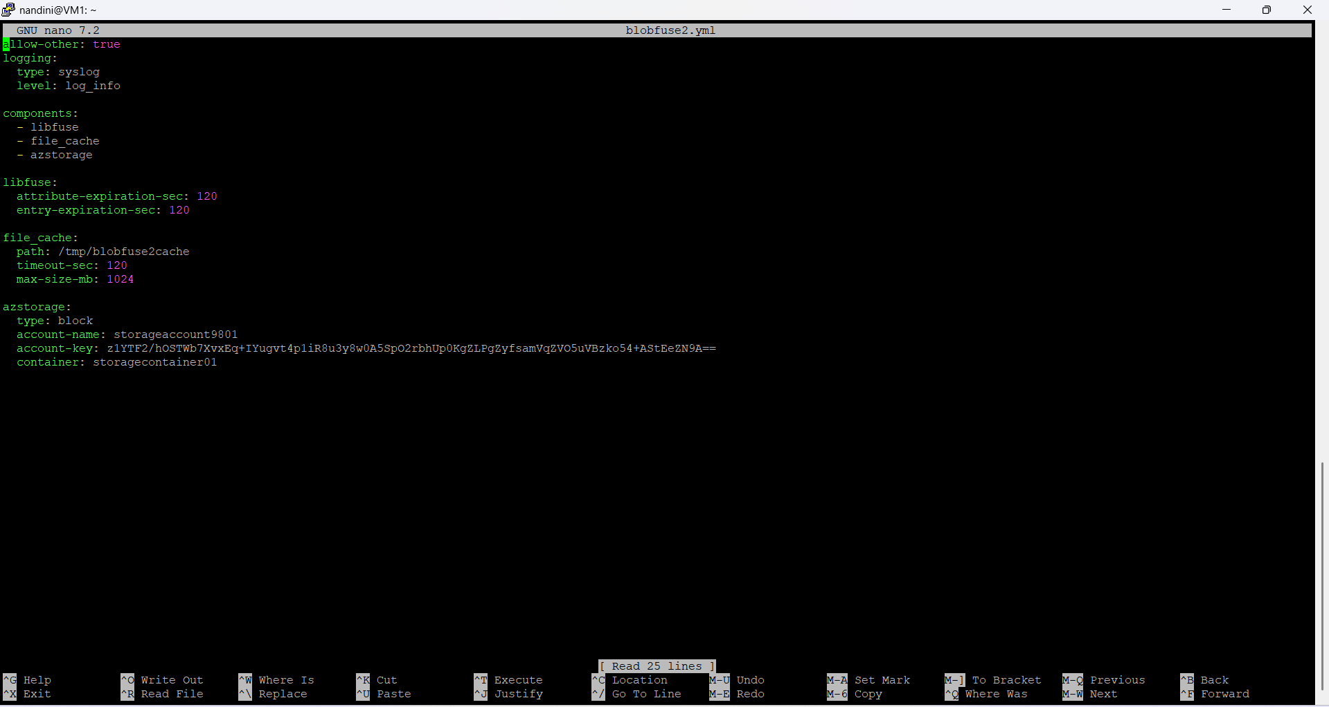

**Step 10:** Create Mount Directory



**Step 11:** Mount Azure Blob Storage



Already mounted we have to unmount using:



Again mount azure blob storage



**lists all files and directories inside the ~/myblob folder**

 It is empty

**Step 12:** Upload a Sample File to Azure Blob



**Step 13:** Verify File Upload

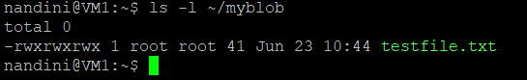

You will see text inside text file



Check the text file visible in container or not 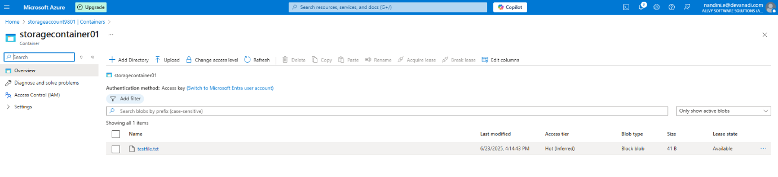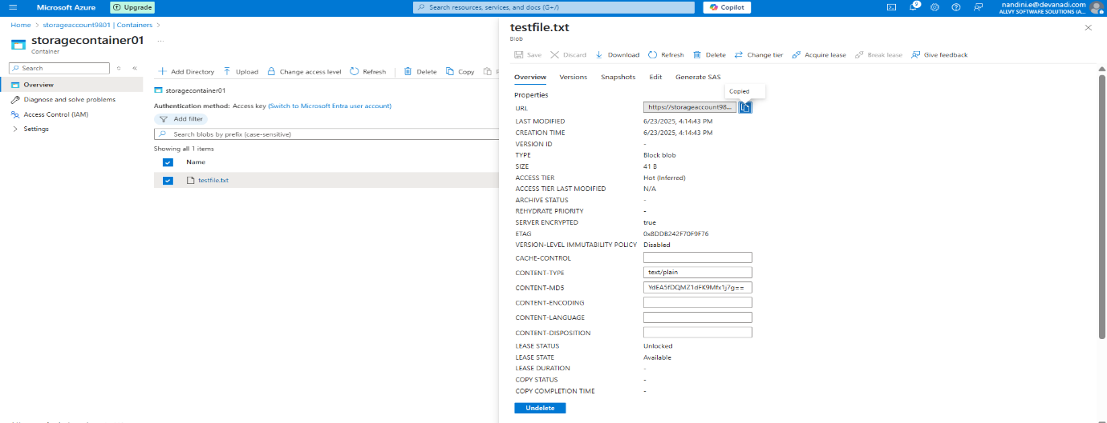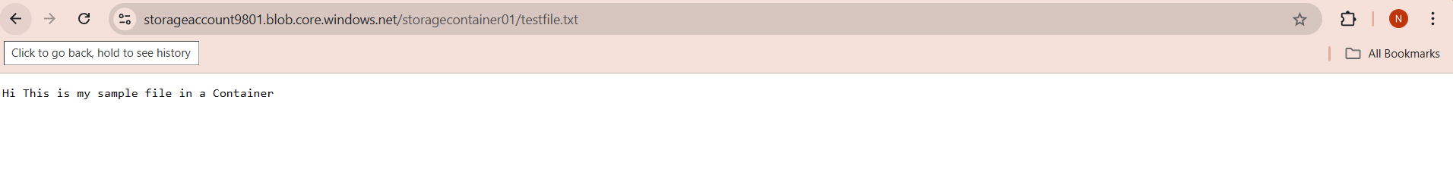 **Step 14:** Confirm Mounting in File System

